**Name: - Akhand Pratap Singh**

**Sap Id: - 500085043**

**EXPERIMENT-6**

create database Experiment6;

use experiment6;

# EMP Table

create table EMPLOYEES(

Employee_id varchar(10),

First_Name varchar(30),

Last_Name varchar(30),

DOB date,

Salary int(25),

Department_id char(10)

);

insert into EMPLOYEES value('7364','SMITH','MARK','1987-12-19','500','800');

insert into EMPLOYEES value('7365','JOHN','JOHN','1987-12-19','1500','802');

insert into EMPLOYEES value('7366','ROSS','GELLER','1987-12-19','5020','803');

insert into EMPLOYEES value('7367','MONICA','GELLER','1987-12-19','5500','804');

insert into EMPLOYEES value('7368','SMITH','CLERK','1987-12-19','5000','805');

insert into EMPLOYEES value('7369','RACHEL','GREEN','1987-12-19','10500','806');

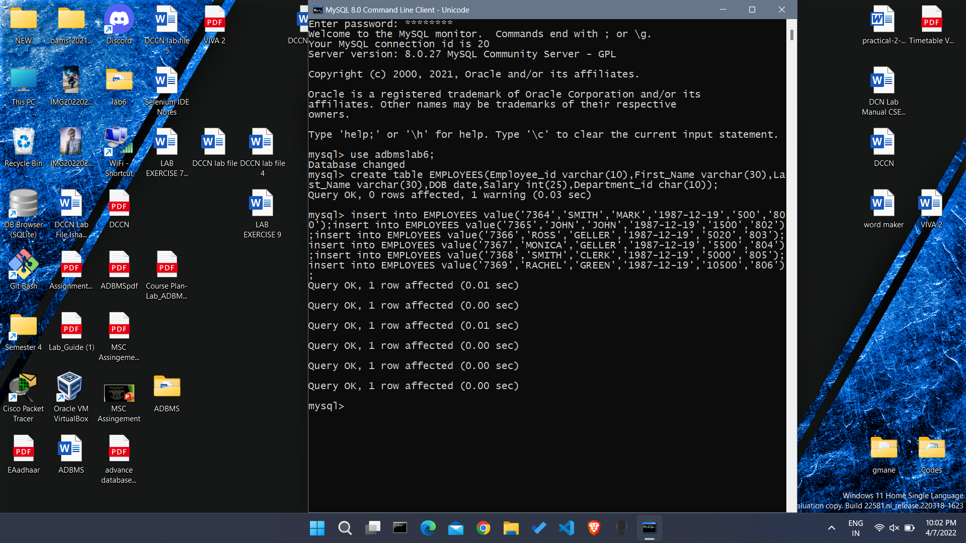

# Question 1

CREATE VIEW emp_view AS SELECT Employee_id, Last_Name, salary, department_id FROM EMPLOYEES;

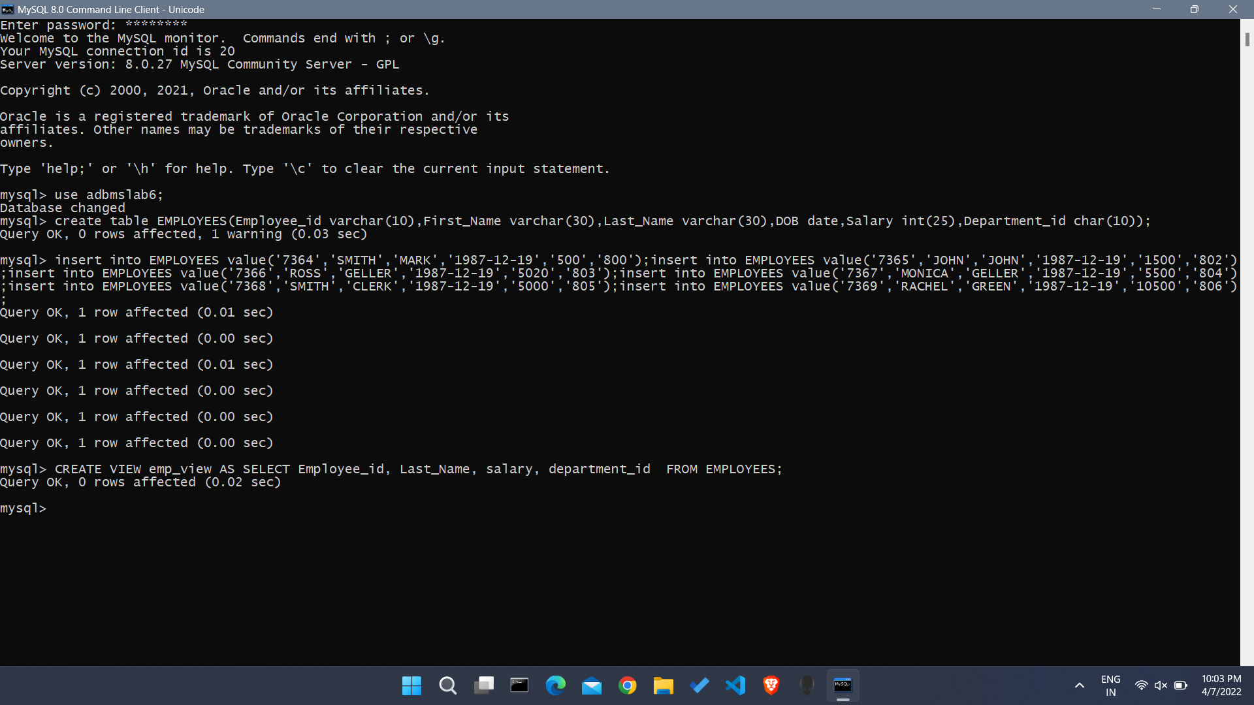

# Question 2

insert into emp_view values('7364','MARK','500','800');

insert into emp_view value('7365','JOHN','1500','802');

insert into emp_view value('7366','GELLER','5020','803');

insert into emp_view value('7367','GELLER','5500','804');

insert into emp_view value('7368','CLERK','5000','805');

insert into emp_view value('7369','GREEN','10500','806');

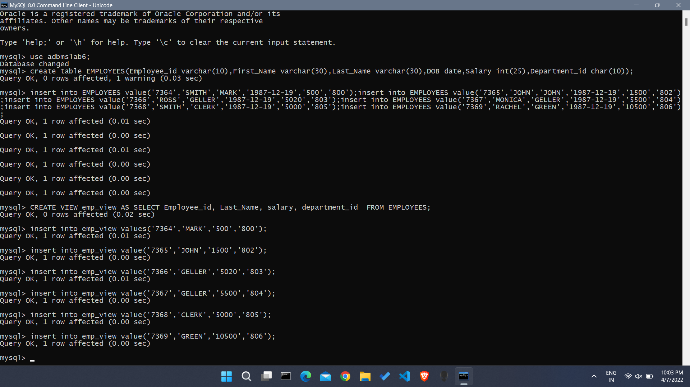

# Question 3

CREATE OR REPLACE VIEW contacts AS SELECT Employee_id, Last_Name FROM emp_view;

DROP VIEW Employee_view;

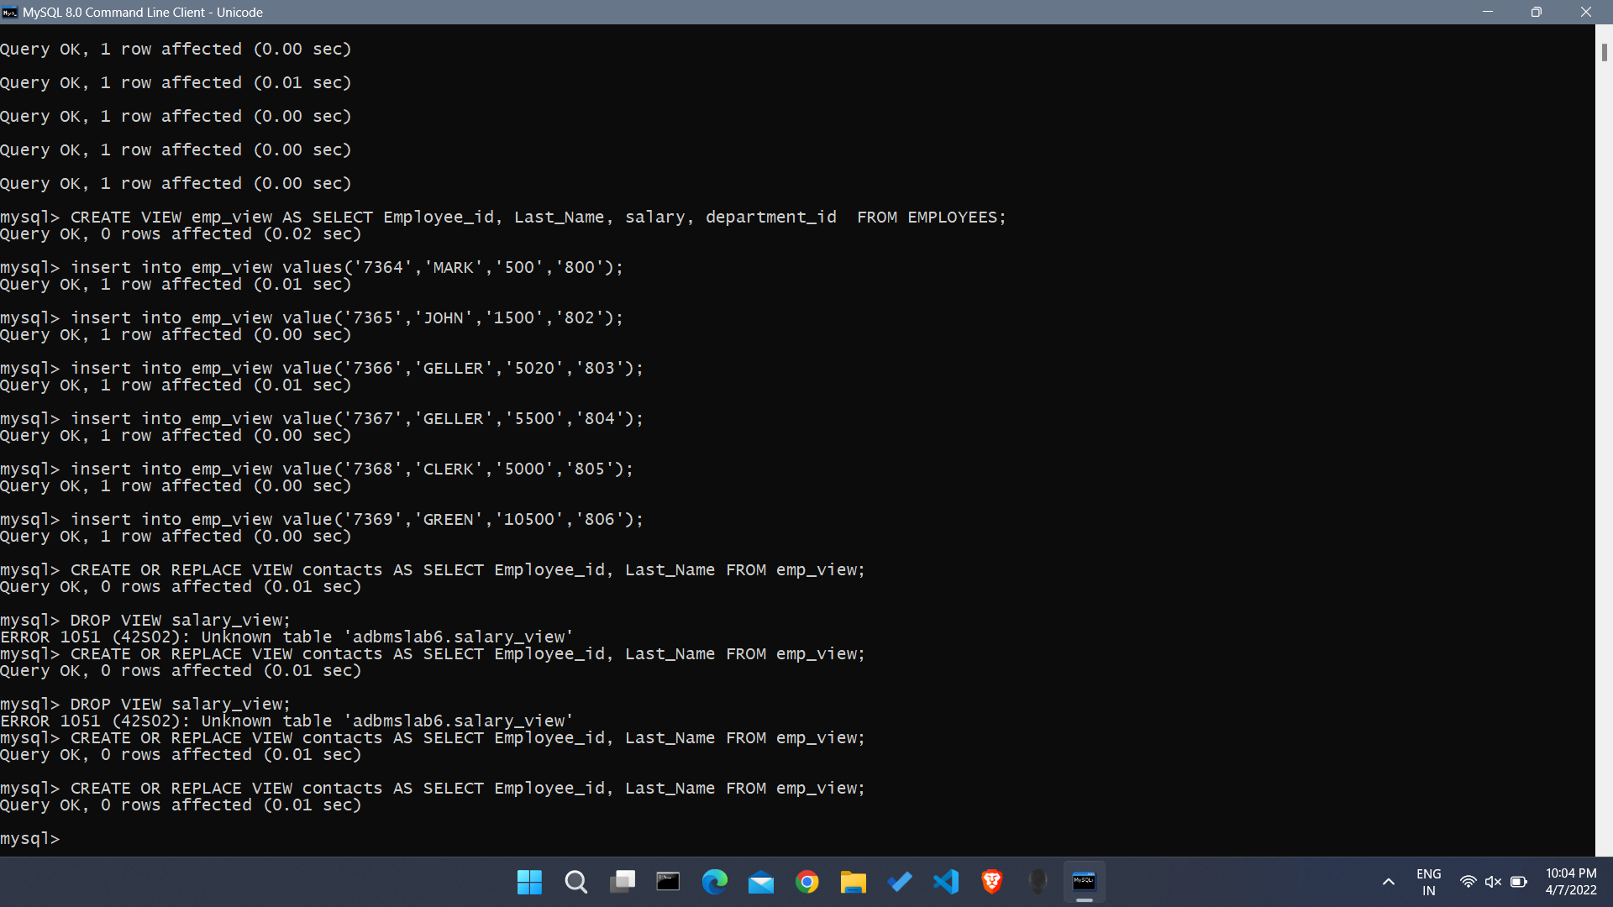

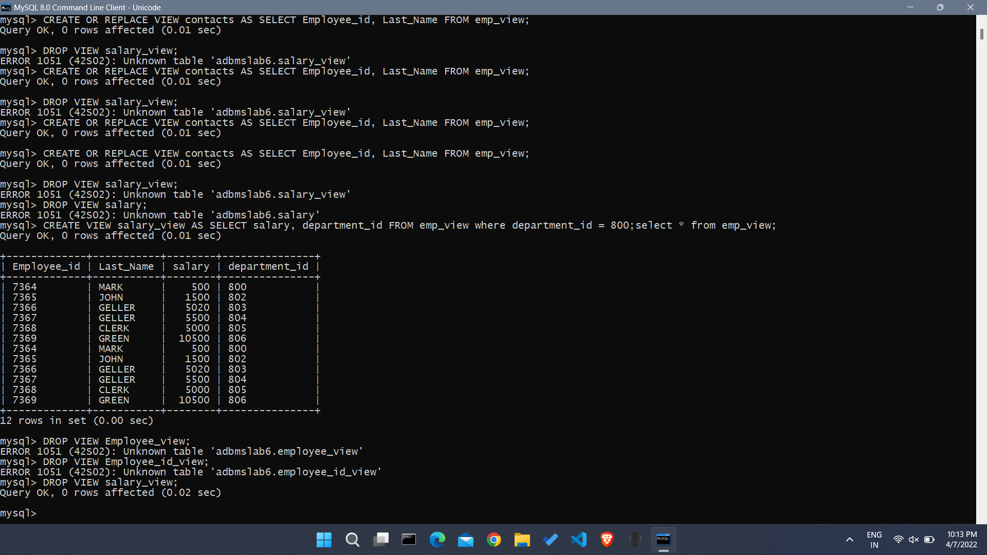

# Question 4

CREATE VIEW salary_view AS SELECT salary, department_id FROM emp_view where department_id = 800;

select * from emp_view;

